

root@cyberster:~$ whoami
> hanzallah — soc_intern
Day
53-57
Event Log & Prefetch Analysis
// candidate Hanzallah
// program Cyberster — Cybersecurity Internship (Batch 2)
// tutor Abdullah Zia
[ STATUS: TASKS COMPLETE — READY FOR REVIEW ]
Local baseline investigation covering live Windows Security event log analysis (Part A, Days 53–55) and Prefetch execution artifact analysis (Part B, Days 56–57), performed against my own machine to establish what normal authentication and execution activity looks like before applying the same techniques to a compromised host.
// 00 ENVIRONMENT & TOOLING SETUP
$ Locating EZ Tools on the Host
Before any parsing could begin, the EZ Tools binaries (EvtxECmd, PECmd) had to be located on the host, since both are launched from PowerShell rather than added to system PATH by default. A recursive search confirmed EvtxECmd was already present under a versioned EZTools directory.
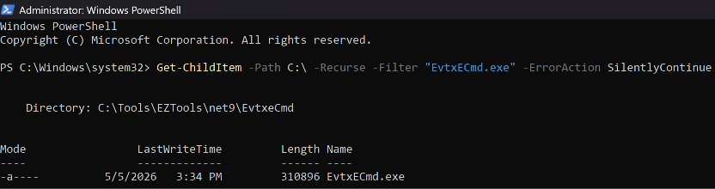
Result: C:\Tools\EZTools\net9\EvtxeCmd\EvtxECmd.exe
PowerShell's dir alias (Get-ChildItem) does not accept cmd.exe-style switches such as /a-d, and PowerShell will not execute a binary from the current folder without an explicit .\ prefix — both are common sources of "not recognized" errors when following instructions written for classic cmd.exe.
$ Resolving PECmd's Location
A repeat search located PECmd.exe, but it was extracted flat into the net9 directory itself rather than its own PECmd subfolder — a packaging inconsistency between the two tool downloads that had to be confirmed before the correct working directory could be used.
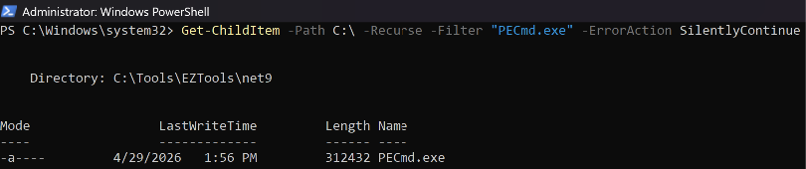
Result: C:\Tools\EZTools\net9\PECmd.exe

$ Prefetch File Count (PowerShell-native)
The task instructions specified a cmd.exe counting pattern (dir /a-d | find /c), which fails under PowerShell's Get-ChildItem alias. The PowerShell-native equivalent was used instead:
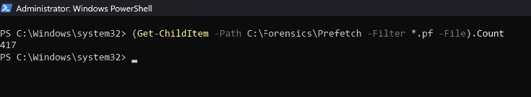
$ Spreadsheet Filtering Method (Excel)
Both parsed CSVs (security_parsed.csv and prefetch_parsed.csv) were analyzed in Excel using AutoFilter rather than Event Viewer's XML filter view, which does not support filtering by multiple simultaneous criteria without hand-written XML.
- Home → Sort & Filter → Filter (Ctrl+Shift+L) to add dropdown arrows to every column header.
- Filtered EventId to isolate 4624, 4625, and 4672 individually per investigation phase.
- Filtered the LogonType / MapDescription column within the 4624 result set to isolate Types 2, 5, and 7 as required per day.
- Where EventId did not sort numerically (imported as text), Data → Text to Columns → Finish was used to force a true numeric type before filtering.

// 53-55 PART A — EVENT LOG ANALYSIS (LOCAL BASELINE)
$ Evidence Acquisition & Integrity
The live Security.evtx log was copied to a working folder prior to any analysis, and a SHA256 hash was generated immediately to establish an evidence integrity record before parsing began.

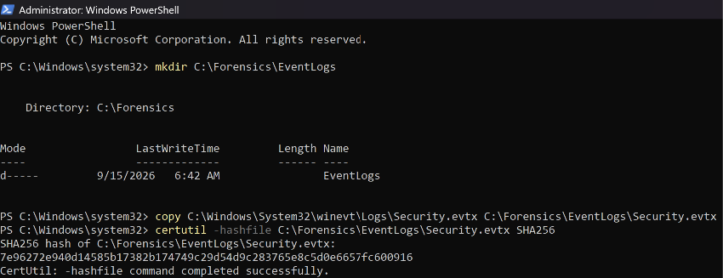
$ Day 53 — Human Baseline (Event ID 4624 / 4625)
Event ID 4624 with Logon Type 2 (interactive console logon) and Logon Type 7 (screen unlock) was used to reconstruct physical working sessions over the preceding 48 hours.
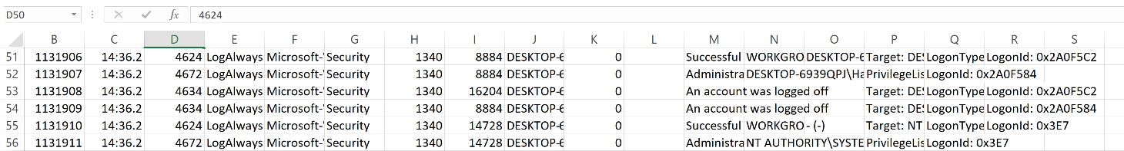

Event ID 4625 (failed logon) was filtered to identify the most recent authentication failure and its associated failure reason code.

$ Day 54 — Privilege Tracking & UAC Auditing (Event ID 4672)
Event ID 4672 (Special Privileges Assigned) fires when an administrator logs in or a process elevates privileges. Timestamps were cross-referenced against known personal activity to confirm legitimate causes for each elevation event.
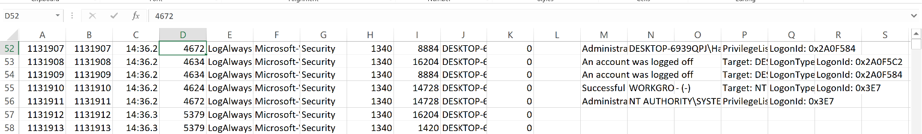

Each event correlates directly to a deliberate administrative action, confirming that privilege escalation on this machine during the observed window was legitimate and user-initiated rather than the result of an unauthorized process.

$ Day 55 — Background Noise (Logon Type 5)
Event ID 4624 with Logon Type 5 (service logon) was isolated to catalogue the built-in accounts responsible for background authentication that should not be flagged as suspicious during an investigation.

Account | Function | Why It Is Not Suspicious
SYSTEM | Highest-privilege built-in account; runs core OS processes and most Windows services. | Authenticates continuously by design across every Windows machine.
LOCAL SERVICE | Reduced-privilege account for services needing minimal local access. | Standard service account, not tied to human interaction.
NETWORK SERVICE | Reduced-privilege account for services needing network access. | Standard service account, not tied to human interaction.
DWM-1 / UMFD-0 | Per-session accounts for Desktop Window Manager and font rasterization. | Created automatically per logon session; present on every session.

No Event ID 1102 (Security log cleared) was observed in the collected window. Had this event been present, it would represent a significant anti-forensics finding warranting escalation.
// 56-57 PART B — PREFETCH FILE ANALYSIS (LOCA MACHINE)
$ Prefetch Collection & Parsing
The live Prefetch directory was copied to a working folder before analysis to avoid modifying original artifact timestamps, then parsed with PECmd.
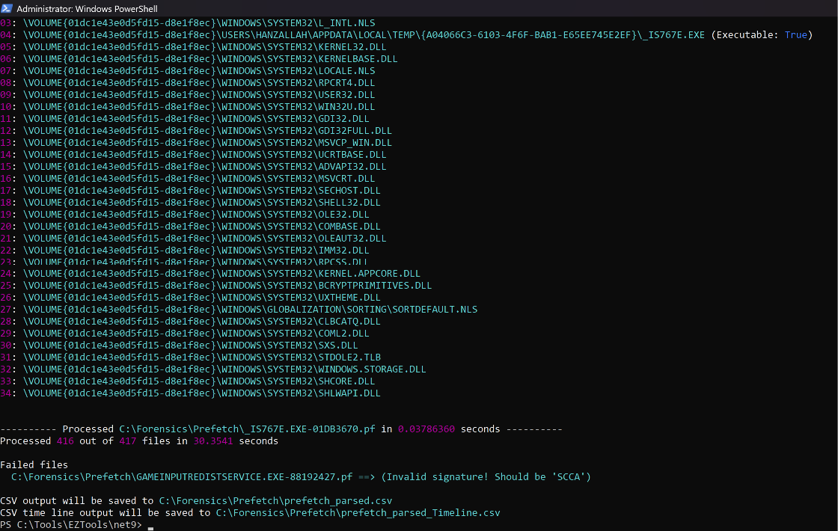

Total .pf files collected: 417
$ Top 20 Executed Programs
Entries were sorted descending by run count to identify the most frequently executed programs on this machine.
